Dear {{Supervisor’s Name}},
I would like to request approval to attend Stukent’s Marketing ProfCon 2023 conference on June 14-16, 2023, in Idaho Falls, Idaho. ProfCon is one of the largest conferences for marketing professors in the United States.

ProfCon provides endless opportunities on and off the agenda to share my research and to network with experts and professionals in the field, potentially leading to further research opportunities.

This conference offers professional development and learning opportunities for professors and professionals across the higher education and marketing industries. ProfCon will feature a variety of sessions; upon approval, I plan to attend sessions focused on {{topic(s)}}, which would enable me to be a part of the solution to the current challenges {{your school or institution}} is facing.

Here are a few comments from previous ProfCon attendees:
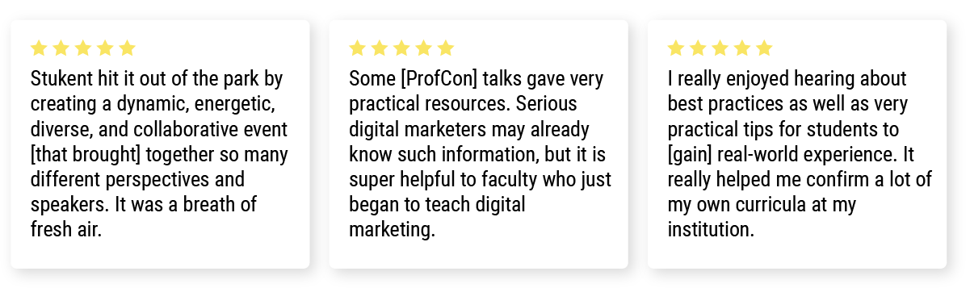
Additionally, attending ProfCon would give me access to new resources, industry updates, leading-edge education trends, and ready-to-implement strategies. It would help me continue to build my skills in {{skill 1}}, {{skill 2}}, and {{skill 3}}.

I am seeking approval for the registration and travel expenditures. If I register now, I will receive a discounted registration rate. Here is the breakdown of the costs:

Conference pass: ${{X}}
Airfare: ${{X}}
Other transportation: ${{X}}
Lodging: ${{X}}
Meals: ${{X}}
TOTAL COST: ${{X}}

Additionally, Stukent offers discounts for educators who purchase their ProfCon tickets early or use at least one of their products.

Complete information on ProfCon 2023 is available at stukent.com/profcon. I would appreciate your consideration of my request, as ProfCon is an invaluable learning experience. Thank you in advance, and I look forward to discussing this with you soon.

Sincerely,
{{Your Name}}

