Kay M. Beckermann, Ph.D.
Kay.beckermann@mnstate.edu
Abstract
This document contains a course map, activities, assessments, and rubrics for COMM 352.
Developed November 2020.
Course Map package
Comm 352: Social Media Campaigns

Table of Contents
Course Information 2
Description 2
Course Objectives 2
Notes 2
Course Map 2
Learning Activities 10
Week 2 Activities 10
Self-Awareness Exercise 10
Visual Description of Social Media 10
Week 3 Activities 12
Group: Social Media Infographic 12
Week 4 Activities 13
Group: Terms of Service Review 13
Think/Pair/Share: The Social Media Landscape in 2020/21 13
Week 5 Activities 14
Social Media Roles: Venn Diagram or Content Map 14
Week 6 Activities 15
Social Media Riff-Off 15
Illustrate Key Categories of Metrics 15
Week 7 Activities 17
Social Media Campaign Elements Crossword Puzzle 17
Week 8 Activities 18
Think/Pair/Share: Strategies and Tactics 18
Week 9 Activities 19
Create a Style and Writing Guide 19
Social Media Communication Audit 20
Week 10 Activities 21
Identifying Audience Segmentation 21
Week 11 Activities 22
Visual Storyboard 22
Week 12 Activities Content Calendar Creation 23
Week 13 Activities 24
Social Media Budget Group Activity 24
Week 14 Activities 25
Paid Metrics Matching 25
Week 14 Activities 26
Paid Metrics Kahoot 26
Assessment Activities 27
Week 2 Assessment Activities 27
Week 2 Discussion 27
Hootsuite Academy Certification Program 27
Week 3 Assessment Activities 28
Mimic Social Simulation 28
Week 4 Assessment Activities 29
Week 4 Discussion 29
Week 5 Assessment Activities 30
Quiz: Social Media Roles 30
Industry Position Analysis 31
Week 6 Assessment 32
Social Media Listening Group Assignment 32
Week 7 Assessment 33
SWOT Analysis Assignment 33
Social Media Audit Group Assignment 34
Week 9 Assessment 35
Community Copywriting Assignment 35
Discussion: Adopting New Writing Styles 37
Week 10 Assessment 38
Influencers, Ambassadors, Creators, Oh my! 38
Week 11 Assessment 39
Discussion National Coffee Day 39
Week 14 Assessment 40
Discussion: Freberg Ch 10 40
Appendices 41
Appendix One: Discussion Rubric 41
Appendix Two: Mimic Social Student Grader 42
Appendix Three: Writing Rubric 43
Appendix Four: Peer Evaluation 44
Endnotes 46

Course Information

Description
COMM 352: Social Media Campaigns is intended to be an introduction to the theory, application and criticism of social media communication for producers of online advertising and public relations campaigns. Students considering using social media as part of their career or seeking to build upon their portfolio for future employers will also benefit.

Course Objectives
- Develop an awareness and understanding of the nature of the communication transaction occurring in a social media campaign.
- Develop an awareness and understanding of the various media platforms encompassed under the rubric of social media.
- Develop a proficiency in the design and construction of a social media campaign targeting a specific public(s) of an extant organization.
- Develop an ability to critically evaluate the effectiveness of a social media campaign.
- Develop entry-level professional proficiency in the execution of a social media campaign.

Notes
- This course map is based on a one-hour/week, online synchronous meeting. Students are expected to work asynchronously the rest of the week.
- Many of the exercises and assignments come from “Portfolio Building Activities in Social Media” by Karen Freberg.

Course Map

Module Title | Module Learning Objectives (Bloom) | Instructional Materials | Learning Activities (In-Class/Homework) | Assessment Activities
Week 1 (Jan 11)  Welcome and Overview |  | - Syllabus^ | - Syllabus Speed “dating” | - Syllabus Quiz, 10 pts^
Week 2 (Jan 18)  Ch 1: Intro to Social Media, An Art and a Science  *Holiday, Jan 18 | - 3.a. Explain the main considerations for using social media strategically | - Read Ch 1 | - Lecture: Main considerations of using SM strategically  - Self-Awareness Exercise (in-class)  - Gary Vee Video  - Complete exercise (p 2, Wkbk) ^
 | - 3.b. Explain the key characteristics of the science and art of social media. |  | - The science and art of social media (ch 1)  - Visually describe social media. | - Discussion (pg 1, wkbk), 16 pts^
 | - 5.e. Demonstrate proficiency in social media campaign creation via Hootsuite Certification | - Hootsuite URL  - Read: Is a Hootsuite Certification Worthwhile? | - Discuss Hootsuite Certification and Expectations | - Begin Hootsuite Certification
Week 3 (Jan 25)  Begin Mimic Social Simulations | - 5.c. Design social media content for Buhi Supply Co. (#6, creating) | - Mimic Social | - Lecture: Overview of Mimic Social in class | - Mimic Social: Round 1
 | - 5.b. Develop a social media calendar for Buhi Supply Co. (6, creating) |  |  | - Calendar creation, ongoing for six weeks^. Maybe.
 | - 5.d. Evaluate analytics of Buhi Supply Co (5, evaluating) |  |  | - Ongoing with each round
 | - 2.c. List the characteristics of various social media platforms | - Read: Charello Slides | - Group Activity: social media infographic  - Best times to post  - Best type of content  - Type of user  - etc
Week 4  Ch 2: Ethical and Legal Fundamentals of Social Media | - #5.a. Outline the legal fundamentals for working in social media (#2, Explain) | - Read: Ch 2  - Read: The Social Media Landscape in 2020 | - Lecture: Legal Fundamentals (pg 35)  - Group: review Terms of Service for social media platforms. Find anything interesting?  - Discussion: Landscape in 2020 (and 2021 if articles exist) | - Discussion: Exercise 2, FTC and Influencers (pg 44)
Week 5  Ch 4: Industry Qualifications and Roles | - 1.a. Compare and contrast social media roles and their communication objectives  - 6.c. Compare and contrast social media roles and how they work together to create a social media campaign | - Read: Ch 4 | - Lecture: Key social media roles (pg 73) | - Quiz: Match definition to role  - Assignment: Industry Position Analysis (pg 17, wkbk)^  - Mimic Social Round 2
Week 6  Ch 5: Research in Social Media: Monitoring, Listening, and Analysis | - 2.a./4.a. Compare and contrast metrics and measurements between platforms | - Ch 5 | - Lecture: types of metrics (p 99) | - Mimic Social Round 3  - Assignment: Illustrate Key Categories of Metrics^
 | - 4.b. Explain the differences between social listening and monitoring |  |  | - Assignment: Social Media Listening (wkbk pg 27)^
 | - Na/ |  | - Social Media Riff-Off (wkbk p 29)
Week 7  Ch 6: Strategic Planning for Social Media | - 1.a. Construct a data- and research-driven SWOT analysis to identify communication patterns (6, creating) | - Read: Ch 6 | - Lecture: SWOT analysis | - Group Assignment: SWOT Analysis (wkbk p 33)^
 | - 3.d. Summarize the key elements of a social media campaign (#2, understanding)
 | - 3.e. Explain the importance of conducting a background eval, situation analysis, and social media communication audit |  | - Lecture: Social media audit  - Activity: internal and external analysis of social media presence (p 125) | - Develop a social media audit
 | - 5.f. Assess social media content for area or campus multicultural organizations (5, evaluating) |  |  | - Group Assignment: create a social media audit for area or campus multicultural organizations
Week 8  Ch 6: Strategic Planning for Social Media | - 3.f. Develop goals, objectives, strategies, and tactic statements for a social media plan (6, creating) | - Read: Ch 6 | - Lecture: goals, objectives, strategies and tactics  - Quiz: Define differences of goals, objectives, etc ^ | - Assignment: Strategic Brief (wkbk p 34)^ This can be the recommendations section of the social media audit conducted earlier
Week 9  Ch 7: Strategic Writing for Social Media | - 1.c. Create messages with appropriate tone and voice for various platforms | - Read: Ch 7 | - Lecture: tone and voice (p 143)  - Group: review style guides for various websites (wkbk p 39)^ | - Assignment: Community Copywriting Assignment (wkbk p 43)^
 | - 2.b. Analyze writing styles for various social media platforms |  | - Lecture: writing styles for social media (p 149) | - Discussion: Benefits and challenges of adopting a new writing style (Exercise 1, pg 159)  - Create 5 different discussion groups, each with a different writing style.^
Week 10  Ch 8: Audience Segmentation and Analysis | - 3.g. Model audiences using segmentation techniques (Table 8.1) | - Read: Ch 8 | - Lecture: audience segmentation  - Discussion: why is audience segmentation important in social media practices?  - Activity: groups “teach” one another about the different segments on table 8.1
 | - Illustrate the differences between influencers, ambassadors, creators, and trolls |  | - Lecture: differences between influencers, ambassadors, creators, and trolls | - Assignment: Create an infographic for each segment
Week 11  Ch 9: Creating, Managing, and Curating Content | - 1.d. Outline the differences between content creation and curation (2, understanding) | - Read: Ch 9 | - Lecture
 | - 1.e. Create messages using a variety of content creation tools (table 9.3) (6, creating) |  | - Group Activity: Visual Storyboard Assignment (wkbk p 65)  - Students “take over” an account | - Discussion: Exercise 2 (Dunkin’ Donuts/National Coffee Day) pg 204^
Week 12  Ch 9: Creating, Managing, and Curating Content  *No Class: Fri, April 2 | - 3.i. Develop a content calendar for social media messages (6, creating) | - Read: Ch 9 | - Ben Sailer (CoSchedule) visit? He spoke about SMART goals in his last visit, so maybe he could speak elsewhere in the semester? | - Assignment: exercise 4 (Student run agency, pg 204)^
Week 13  Ch 10: Measurement, Evaluation, Budget, and Calendar  *No class, Mon, April 5 | - 3.j. Estimate a budget based on paid metrics (6, creating) p 219 | - Read: Ch 10 | - Lecture: Budget  - Group Assignment: Social Media Budget (wkbk p 73)…maybe? | - Group Assignment: Paid Media Assignment: Facebook and Instagram (wkbk p 71)
 | - 4.c. Summarize the AEMC framework for evaluation of campaigns (2, understanding) |  | - Lecture: AEMC Framework (Table 10.1)  - Activity: students “teach” each other about the AEMC framework instead of lecture?
Week 14  Ch 10: Measurement, Evaluation, Budget, and Calendar | - 4.d. Explain the various techniques, metrics, and tools used for measurement and evaluation (#2, understanding) |  | - Lecture: paid metrics, outcomes, and implications (table 10.4)  - Activity: Flippity matching | - Discussion
 | - 4.e. Distinguish the differences between measurement objectives (table 10.2) (4, analyzing) |  | - Lecture: Cognitive, attitudinal, and conative measurement objectives (table 10.2)
Week 15  *No Class: April 20, Student Academic Conference | - Work Day
Week 16 (May 3)  Wed, May 5: Study Day  Finals begin: May 6 | - TBD

Learning Activities

Week 2 Activities

Self-Awareness Exercise
Learning Objective: 3.b.
Location: In-Class
First, watch Gary Vaynerchuk’s self-awareness video in class. Then answer the following questions:
- How would you define social media? List any attributes that come to mind.
- How would you characterize yourself as a social media user?
- How would you characterize yourself as a social media strategist? Provide evidence and support for your answer.
- One a scale from 1 (not at all) to 5 (completely), how self-aware are you about your social media work? Discuss how this applies to what Gary Vaynerchuk highlighted in his video.
- What do you consider to be your strengths in your understanding of social media? What are your challenges?
- What are some takeaways you hope to get from this class?
- During this class, we will complete several exercises and assignments. How confident are you that you will be able to master each of the following?
  - The content for the class
  - Assignments
  - Exercises (in and out of class)
  - Presentations
- How confident are you in the content for this class? What areas are you most concerned about? List these and explains. Discuss steps you will take to address these challenges during the class.
- What are three goals you have for this class and beyond?
These questions will be reviewed again at the end of the semester.

Visual Description of Social Media
Learning Objective: 3.b.
Location: In Class
Social media is both a science and an art, so it is important to emphasize the creativity of what can be accomplished using social media. Creativity is a process, and this exercise will help in creating more opportunities to formulate your own vision of what creativity means to you, but also for how it can be applied in a social media context. It is important not only to have a great idea, but to be able to execute it effectively and strategically.
Describe what social media means to you visually. How would you do this? Pick one of the following creative options to help you share how you would define social media
- Draw what social media means to you.
- Create a 3x3 grid (nine total boxes) and choose nine emojis that represent your view of social media.
- Make a social media mood board or collage on what comes to mind when you think of social media.
- Create a 15-second video (TikTik, Instagram Reels, other) showing what social media means to you.

Week 3 Activities
Group: Social Media Infographic
Learning Objective: 2.c.
Location: In Class
Groups of 2-3 students will be assigned a social media platform (Facebook, Instagram, Twitter, etc). Each group will use Canva or Adobe Spark to create an infographic detailing the following:
- User demographics of assignment platform
- Best times to post content
- Best day to post content
- Best type of content to post
- How to best encourage engagement
Students will upload the infographics to D2L for class sharing and discussion.

Week 4 Activities
Group: Terms of Service Review
Learning Objective: 5.a.
Location: In Class
Groups of 2-4 students will review the terms of service for a variety of social media platforms. Each group will highlight three items that are of particular interest to share with the class.

Think/Pair/Share: The Social Media Landscape in 2020/21
Learning Objective: 5.a.
Location: In Class
After reviewing the web article titled “The Social Media Landscape in 2020/21”, students will write down one or two items of interest, share with their neighbor for discussion, and then share/discuss with the class.

Week 5 Activities
Social Media Roles: Venn Diagram or Content Map
Learning Objective: 6.c.
Location: In Class
In groups, students will discuss how the various social media roles work together to create an effective social media site an any given platform. They will then illustrate how these roles work together via a Venn Diagram, Content Map, or other.

Week 6 Activities
Social Media Riff-Off
Learning Objective: n/a*
Location: In Class
Inspired by the movie Pitch Perfect. Students will gather into groups and come up determine which brand they represent. Each team has to create updates in real time based on the topics at hand to try to be as relevant as possible for its personal brand. Brands have been able to do this well in some cases (i.e. Wendy’s, Oreos) but others have not.
Each team member is responsible for coming up with a social media update to share with the class. Each chance will last five minutes. If a student is stumped or their update is not appropriate, the team is out of the competition. Once a team is out, the next topic is chosen. The last remaining team wins.
Each group must research and determine their brand voice.
Suggested brands include, but are not limited to:
- Pepsi
- Charmin
- Cinnabon
- Coca-Cola
- Arby’s
- Taco Bell
- Wendy’s
- KFC
Example topics include, but are not limited to:
- Star Wars Day (May the Fourth Be With You)
- Halloween
- National Coffee Day
- Mother’s Day
- National Spaghetti Day
- Back to School
Use the Spin the Wheel app to select each topic.
Winners receive a D2L badge, bragging rights, and, if in person, a pen from Big Iron.
*While this does not fit a learning objective, it is a fun way to break up the semester while practicing social media skills.

Illustrate Key Categories of Metrics
Learning Objective: 2.a., 4.a.
Location: In Class
In groups, students will illustrate the metric categories used in social media. They can use Table 5.2 (page 100) as a basis for their illustrations.
The illustrations can be diagrams, hand drawn cartoons, videos, computer graphics – whatever tool will help them visually demonstrate their understanding of the metrics and what they measure.

Week 7 Activities
Social Media Campaign Elements Crossword Puzzle
Learning Objective: 3.d.
Location: In Class
How can I make this online and interactive? http://puzzlemaker.discoveryeducation.com/CrissCrossSetupForm.asp
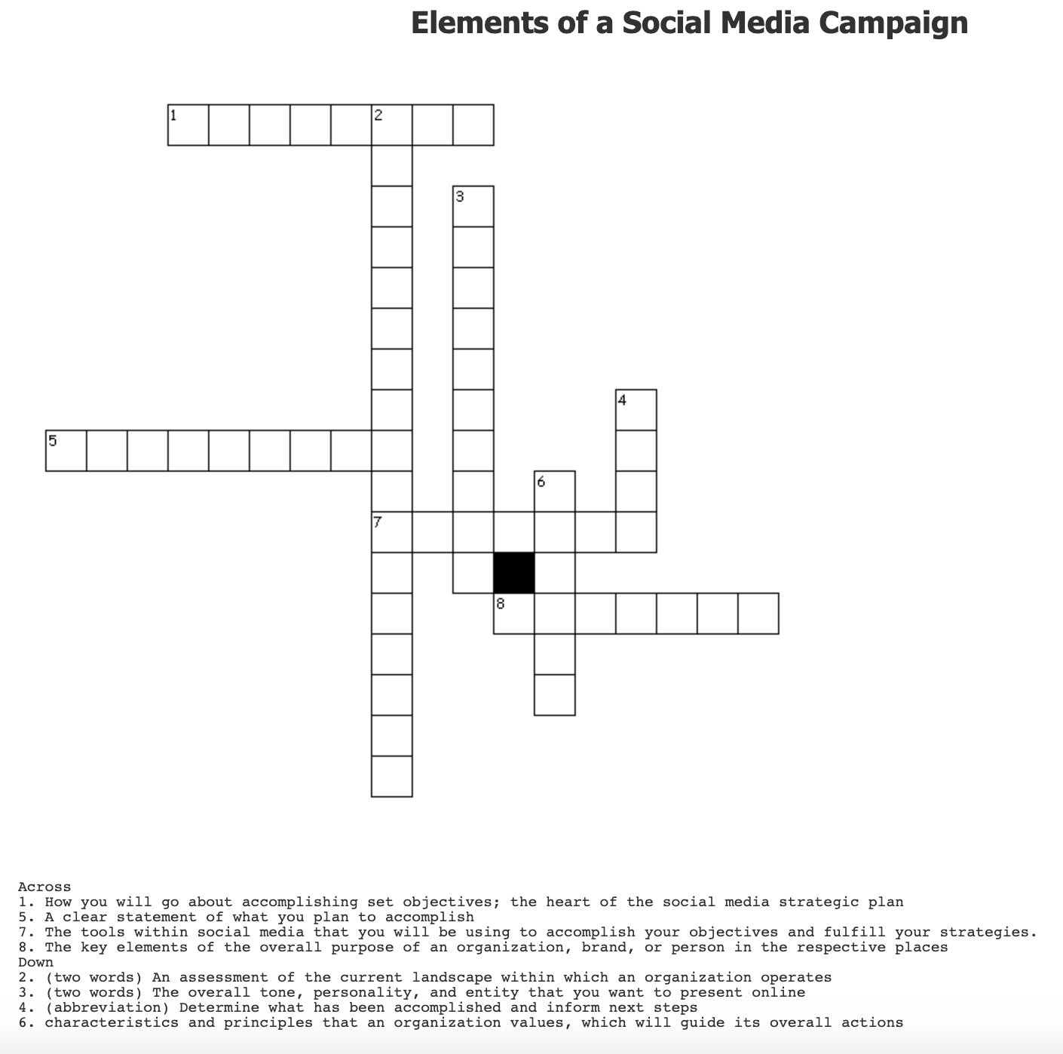

Week 8 Activities
Think/Pair/Share: Strategies and Tactics
Learning Objective: 3.f.
Location: In Class
In small groups, students will discuss the following prompt and share with the class.
Samsung is looking to engage and build brand awareness with Generation Z about its new Samsung Notes product. Write two primary messages and two secondary messages for this audience. Be sure to do your research about Gen Z! Then, propose one strategy and two tactics you could implement to reach this audience for Samsung.
After sharing with the class, peers will then offer suggestions as to how you could evaluate the effectiveness of this campaign.

Week 9 Activities
Create a Style and Writing Guide
Learning Objective: 1.c
Location: In Class
Work in small groups.
Prompt: You are asked to create and launch a style and writing guide for your internship. Choose an agency, brand, or company you want to work for. Research and evaluate its style guide to determine if anything needs to be added or changed as far as the writing and visual style goes.
Outline the following:
- Writing style
- Voice and tone
- Content types
- Content elements
- Visual elements (Brand kit, colors, typography, etc)
- Guidelines and best practices.

If brands need to be assigned, consider:
- University of North Carolina at Chapel Hill: https://identity.unc.edu/
- MailChimp: https://styleguide.mailchimp.com/
- Atlassian Design System: https://atlassian.design/
- MSUM: https://www2.mnstate.edu/marketing/visualidentitystandards.aspx
- Cisco: https://www.cisco.com/c/m/en_us/about/brand-center/copyright-use/copyright-material-guidelines/interactive-brand-book.html
- New York University: http://www.nyu.edu/content/dam/nyu/cmsTeam/documents/socialmedia/NYU_SocialMedia_StyleGuide_092914.pdf

Social Media Communication Audit
Learning Objective: 3.e.
Location: In Class

Using Public Relations Student Society of America-MSUM Chapter as an example, students will work as a class to complete the internal and external social media audits. If a PRSSA member is in the class, they will be invited prior to class if they are comfortable sharing this information. If not, the instructor will act as the PRSSA representative.
Internal Analysis of Social Media Presence
 | Background | Content + Rationale | Strengths + Weaknesses | Action Steps & Recommendations
Internal Comm.
Personnel + Team Analysis
Education + Mentorship
Employee Social Media Policy
Leadership
Brand Voice
Analytics

External Analysis of Social Media Presence
 | Bkgd | Brand Voice | Relationship / Rationale | Content + Rationale | Strengths + Weaknesses | Action Steps & Recommendations
Platform
Campaigns
Influencers
Community Analysis
Content Creation / Message Analysis
Analytics

Week 10 Activities

Identifying Audience Segmentation
Learning Objective: 3.g.
Location: In Class

Students will work in groups to analyze four different audiences for MN State University Moorhead. Discuss each of the audiences based on the following categories. You will then present your findings to the class. Students will take notes during presentations and be prepared to ask questions.

Audiences: traditional freshman, second-year transfer, non-traditional student, older adult/lifelong learning

- Introduction to the audience group
- Demographics
- Psychographics
- Platform specifics
- Types of social media users
- Certain behaviors they have on social media (e.g. social media metrics)
- Content that resonates with them on social media
- Relationship
  - Discuss the current relationship these audiences have with the university offline.
  - Discuss the current relationship these audiences have with the university online.
- Recommendations for engaging with them on social media.
  - Provide three ways you would recommend approaching this particular audience group on social media.

Week 11 Activities

Visual Storyboard
Learning Objective: 1.e.
Location: In Class

Students will work in five groups.

Your team (named after a famous dragon) has been asked to take-over the MSUM social media accounts as assigned. Your goal is to create a visual storyboard of the content you would like to create. You must create a minimum of five messages that take place throughout the day. Be prepared to share with the class.

Team 1: Scorch
Team 2: Smaug (The Hobbit)
Team 3: Mushu (Mulan)
Team 4: Toothless (How to Train Your Dragon)
Team 5: Haku (Spirited Away)

Team Name:
Objective:
Audience:
Date:

Complete the table for each message
Visual (images, type):
Time to post:
Audio:
Script:

Week 12 Activities
Content Calendar Creation
Learning Objective: 3.i.
Location: In Class

Your group is part of a student-run ad/pr agency and you have been tasked to outline a content marketing strategy to gain awareness about your group on campus. Create/script three messages using specific areas on Table 9.2 (p 194). Create a sample content calendar outlining when each of these proposed items will go out and on what platforms.

Be prepared to share with the class and offer suggestions to other teams

Week 13 Activities
Social Media Budget Group Activity
Learning Objective: 3.j.
Location: In Class
One of the hardest things to do for a social media campaign is to justify the work for a social media initiative or educational training session. In your group, be sure to provide sound estimates, details of the materials and tools needed, and a rationale for this investment. Along with accounting for the cost of tools, time, data, measurement, and education, providing a rational for why these are necessary is key.
Your group will be assigned one of the following:
- Social media campaign
- Influencer marketing campaign
- Creative execution plan for a new platform
Be sure to account for all of the associated costs for tools, time, management and analysis of data; content creation (tools, talent, time, etc); and necessary educational training. Justify your points for each cost associated with each section of your budget.

Below is a template for creating a budget; you may or may not need each section.

Be prepared to present your findings during the next class session.

Strategy | Details | Quantity | Cost | Total Projected Cost | Rationale
Tactic 1
Tactic 2
Measurement
Content Creation
Education or Training
Total Costs:

Week 14 Activities
Paid Metrics Matching
Learning Objective: 4.d.
Location: In Class

Students will use this link: https://www.flippity.net/ma.php?k=1JCTjCfW6IbY2wP86shxvNc-VaopRIvyCHDczADeS7E0 to sort descriptions, applications, and outcomes in appropriate categories.

This link was created using Flippity.com, template at https://docs.google.com/spreadsheets/d/1JCTjCfW6IbY2wP86shxvNc-VaopRIvyCHDczADeS7E0/edit#gid=0

The purpose of this activity is to reinforce terms and their actions.

Week 14 Activities

Paid Metrics Kahoot
Learning Objective: 4.d.
Location: In Class

After a brief lecture discussing paid metrics in social media budgets (see Freberg, p 219 for details), students will play the Paid Metrics Kahoot game. Answers for the game can be found on Table 10.2 (Freberg, page 215) and Table 10.4 (Freberg, page 219).

Winners will receive a D2L badge.

Assessment Activities

Week 2 Assessment Activities

Week 2 Discussion
Learning Objective: 3.a.
Score: 16 points
Rubric: Appendix One
Location: Homework
Think of how social media can help solve a big problem or opportunity. In your opinion, what big problem facing the world can social media address? Use your imagination when considering how social media can help address and solve this problem.

Hootsuite Academy Certification Program
Learning Objective: 5.1.
Score: 100 points
Rubric: n/a, graded on completion
Location: Homework
For this class, everyone will be participating in the Hootsuite Higher Education program. Hootsuite is a social media dashboard that allows individuals and brands to monitor, listen, and engage with their audiences across multiple platforms in a centralized location.
More information about the program can be found on D2L. It is also recommended to follow Hootsuite University on Twitter during this course (@Hootsuite).
For this assignment, you will need to (1) complete the Hootsuite University exams and watch the videos with the downloadable workbooks as part of the certification program, (2) announcing your certification in social media once you have completed Hootsuite University and received the official notification with the class hashtag #Beckermann352, (3) submit your certificate to D2L, and (4) create a post using Adobe Spark Page about your experience with Hootsuite and lessons learned from the experience.
- Learning Objective: 5.1.
- Score: 100 points
- Rubric: n/a, graded on completion

Week 3 Assessment Activities

Mimic Social Simulation
Learning Objective: 5.b-d
Score: 100 points
Rubric: See Appendix Two
Location: Homework
The Mimic Social simulation will give you a taste of what it is like to run a social media marketing campaign for a business.
You will run the social media marketing strategy for Buhi (boo-hee) Supply Co., an e-commerce and retail bag supplier. It specializes in backpack, purse, wallet, satchel, and duffel products. Its business goals are to find bags that resonate with a design-conscious audience, manufacture them at affordable costs, and sell them for a profit at competitive prices.
Buhi aims to design functional bags that evoke nostalgia, bags with enough personality for even the choosiest of Millennials. This goal has been a driving factor that has helped Buhi's sales grow significantly since it was founded in 2009. Your role as the social media manager is to help Buhi reach this goal by increasing the number of visitors on its website. There are twelve rounds to the simulation wherein you will be required to create seven to 12 social media posts per week per platform, or one to two per day. A round will be completed each week of the semester for a total of 12 weeks. You will be responsible for analyzing your content's performance to determine the optimal number of posts for each platform, as well as the channels you believe will best promote Buhi products. You will also have a $5,000 weekly social media advertising budget to promote posts.

Please see the syllabus for weekly simulation deadlines.
It is likely that you will not do very well for the first round or two, but that is all right. Don't worry. Your experience with the simulation, combined with the lesson materials, will help prepare you for success in social media marketing. You will not be graded on the first two simulation rounds.

Week 4 Assessment Activities

Week 4 Discussion
Learning Objective: 5.a.
Score: 16 points
Rubric: See Appendix One
Location: Homework
Influencer marketing and engaging with a large audience online has become a trend for businesses and brands. You have been asked to engage with influencers as part of the Kentucky Derby Festival (KDF), a nonprofit organization of local events in Louisville before the Kentucky Derby. What would you advise the KDF to keep in mind when it comes to working with influencers based on FTC regulations? Write a few of these points down, and for each point, discuss how you would address it proactively and some of the risks to avoid.

Week 5 Assessment Activities

Quiz: Social Media Roles
Learning Objective: 6.c.
Score: 8 points
Rubric: correct score
Location: In-class
Match the social media role to the correct definition.
Role | Definition
Social Media Community Manager | A professional who can add a personal take on the conversation and engagements with audience members
Content Creator | Someone who is well versed in the ability to create pieces of work that resonate with audiences
Consultant | A specialist who provides counsel and advice on social media-specific projects and campaigns.
Freelancer | Someone who is paid for specific projects, items to create, and products on a project basis.
Social Media Coordinator | A professional who focuses on the strategic planning and execution of the social media content for a brand or organization.
Social Media Strategist | A professional who ties in the goals and objectives for the company or client in question, and focuses on how to get these measures accomplished.
Multimedia/Video Producer | A person assigned to the creation, production, and recording of video content to tell effective stories.
Writer/Editor | A professional well-versed in the practice writing and edition content that is consistent with the brand voice.

Industry Position Analysis
Learning Objective: 6.c.
Score: 20 points
Rubric: See Appendix Three
Location: Homework
You are asked to provide an overview of the current state of the social media profession for class. Your responsibility to identify three potential jobs you want to apply for and analyze them based on certain competencies. You will then be asked to decide what position you will be applying for and how you will approach this task. Create a three-page (max) report on your analysis for each job.
Positions can be selected through sites like Indeed.com, LinkedIn, or the brand websites. Discuss the following:
- Overview of the job postings you have chosen.
  - Outline the three job postings you selected and have a rationale for selection.
- Similarities and differences.
  - What experiences, skills, and responsibilities are similar for all of these jobs? What are some of their differences?
- Job requirements.
  - Outline the key certifications, programs, and tools each job states as key components to be knowledgeable on. Outline which once you have and others in which you will work to gain experience.
- Content creation.
  - Using Canva or Adobe Spark, create three pieces of content you will need to have in place before you apply for this position.
  - Some examples include LinkedIn Note, Adobe Spark or Canva cover letter and resume, Instagram Reel and Resume, and more.

Week 6 Assessment

Social Media Listening Group Assignment
Learning Objective: 4.b.
Score: 45 points + 5 point peer evaluation (Appendix Four)
Rubric: See Appendix Three
Location: Homework
Students will work in groups of 3-4. They are asked to evaluate a brand, nonprofit, or organization of their choice by using a free trial of a social media listening tool. A list of free tools can be found at https://blog.hubspot.com/blog/tabid/6307/bid/29437/20-free-social-media-and-brand-monitoring-tools-that-rock.aspx. Each evaluation will cover a two-week time period. A written document will be submitted for grading.
- Overview of the listening tool you will be using.
  - Discuss the tool’s features, advantages and disadvantages.
- Overview of the client.
  - Briefly discuss the account you are analyzing and what is has done – or is not doing - on social media.
- Provide an overview of the use of vanity metrics, channel metrics, advanced metrics, and behavioral metrics. Which ones will you use in this report and why?
- Overall sentiment of the content for all of the platforms.
  - What channels are the most positive? Negative? Neutral? What does this say about the community using each of these platforms?
- Communities and influencers.
  - Screen capture their communities’ network and discuss what the communities mean for the client.
  - Outline and discuss key influencers you feel your client needs to reach out to that would be relevant and necessary in this campaign. When you are discussing influencers, make sure to 1) analyze them, 2) outline their audience, and 3) note their community and network. How is this relevant to your brand?
- Competitive analysis.
  - Run a comparison of the competitors for your brand. You will need to include three competitors in this analysis for the section.
    - Utlize filters for this. Make sure to focus on certain areas and locations for this project.
    - Look at what the community online is saying about these attractions. How is the overall sentiment? Who are the main influencers? What does your community look like online? What hashtags are people using?
- Recommendations and strategic insights
  - What are the main findings from this analysis?
  - Organize findings and statistics found from data collected in a SWOT analysis.

Week 7 Assessment
SWOT Analysis Assignment
Learning Objective: 1.a.
Score: 20 points
Rubric: See Appendix Three
Location: Homework
You are about to interview with the company of your dreams for a summer social media internship, and you have to do your research ahead of your interview. Compile the information below in a Word document.
- Overview of the company.
  - Discuss this company and why you want to interview with them. What has the company done on social media that really inspires you? Who oversees social media at the company? What is their background and what initiatives have they taken on social media (campaigns, new partnerships, news articles and features, awards, etc)? Do they hire an outside agency for their creative work?
- Brand voice.
  - What is the company’s brand voice? What characteristics would you use to describe its overall content, tone, and community on social media? Outline two of the company’s recent efforts on social media.
- SWOT analysis.
  - Look at the company’s current campaigns and channels and discuss its strengths, weaknesses, opportunities, and threats as a brand on social media. Highlight social media campaigns the company has implemented in the past. Use analytics (e.g. vanity metrics, analysis of content, which audiences the company is reaching, and whether or not it has influencers, bots, or key professionals as followers) in your analysis.
  - Create a visual with these insights, and then a rationale summarizing why you have listed each point. Include at least two references for each section (2 references x 4 sections = 8 references total) to back your rationale with evidences.
    - Strengths, Weaknesses, Opportunities, Threats
- Strategic Implications.
  - Last, write two strategic implications the company needs to note for future social media campaigns. Focus on how you will present these data in your interview (video, infographic, etc). You do not need to make a video, for example, just explain how it will be used.
- References.
  - Be sure your references are properly cited using APA style.
  - Visit https://owl.purdue.edu/owl/research_and_citation/apa_style/apa_style_introduction.html for APA style details.

Social Media Audit Group Assignment
Learning Objective: 5.f.
Score: 50 points
Rubric: See Appendix Three
Location: Homework
Groups of 3-4 students will be assigned a MSUM student organization with which to develop a social media audit. In order to meet campus strategic plan, the instructor will work with the Office of Equity and Diversity to find suitable organizations with which to work. Students will have two weeks to complete the assignment.
Students will meet with the student organization to obtain background information and complete the Internal Analysis of Social Media Presence. They will then complete the External Analysis. Finally, students will write a 5-page (maximum) report summarizing the analyses and outline next steps. The report will be graded, and the corrected version will be given to the student organization.
Step 1: Receive assigned group
Step 2: Research the organization. What is their mission? Location on campus? Board of directors? Activities on and off campus? Other?
Step 2: Reach out to the organization; set up a time to meet for discussion of the internal audit
Step 3: Complete the internal analysis
Step 4: Complete the external analysis
Step 5: Write a five-page (max) written report summarizing findings and provide next steps.
Step 6: Submit to D2L for corrections
Step 7: Submit to the student organization

Week 9 Assessment
Community Copywriting Assignment
Learning Objective: 2.b
Score: 10 points
Rubric: TBD
Location: Homework

You are invited to be part of the interview process for a social media community content creator and manager role. The company you are working for is Converse. You are asked to create content fo rhte company on social media based on the images presented. Write down the copy. You would write for each image based on your understanding of the brand, and provide a rationale for why you wrote the copy for each image.

Note: Images used with permission via Creative Commons. See Endnotes for details.

Platform | Image | Copy  What copy would you write for these images? | Rationale  Why did you approach this copy in this way?
Facebook
Twitter
Instagram

Discussion: Adopting New Writing Styles
Learning Objective: 2.b
Score: 16 points
Rubric: See Appendix One
Location: Homework

This discussion will be divided into four groups, each featuring a different writing style but same prompt. Students will be randomly placed in a group and they will respond to their peers in the group.

Writing styles include snarky, humorous, inspirational, and audience focused.

You are the social media manager for a local school system. Some of your colleagues have been watching some larger brands be creative with their writing style, embracing a “_______” approach. What are some benefits and challenges you would want to identify in this writing style for your client?

Your post must be a minimum of 100 words.

Respond to at least one classmate.

Week 10 Assessment
Influencers, Ambassadors, Creators, Oh my!
Learning Objective: 3.g.
Score: 20 points
Rubric: TBD
Location: Homework

Review the information regarding Influencers, ambassadors, creators, and trolls. Pay particular attention to Table 8.3 on page 179 of your textbook.

Then, visually demonstrate (picture, video, infographic, etc) the differences between each of these groups.

Submit your visual representation on D2L.

Week 11 Assessment

Discussion National Coffee Day
Learning Objective: 3.g.
Score: 16 points
Rubric: See Appendix One
Location: Homework

As part of your entry exam for a new position, Moxie Java wants you to create an editorial calendar outlining its celebration coming up for “National Coffee Day.” Outline some recommendations for how the company should prepare for this national holiday.

Your post must be a minimum of 100 words. Don’t be afraid to be creative!

Respond to at least one classmate.

Week 14 Assessment

Discussion: Freberg Ch 10
Learning Objective: 3.j.
Score: 16 points
Rubric: See Appendix One
Location: Homework

Students will be randomly placed into two separate groups for this discussion. They will post and respond only to members of their assigned group; each group will have a different question.

Group 1: You are told during a job interview that “measurement doesn’t matter” in regard to social media. Provide at least one reason why measurement is imperative to any social media campaign. Explain your answer.

Group 2: You have been given $100 to create a social media campaign for next week’s episode of Saturday Night Live with guest John Mulaney. Discuss your recommendations for the budget, which platforms you would use, and your rationale for approaching the campaign this way on social media.

Your post must be a minimum of 100 words.

Respond to at least one classmate.

Appendices

Appendix One: Discussion Rubric

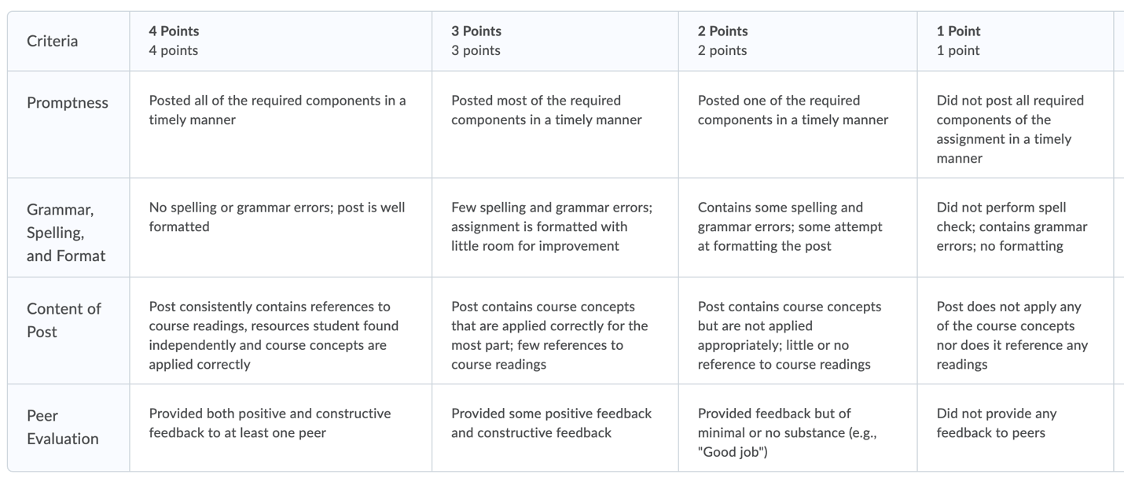

Appendix Two: Mimic Social Student Grader
Located in Excel

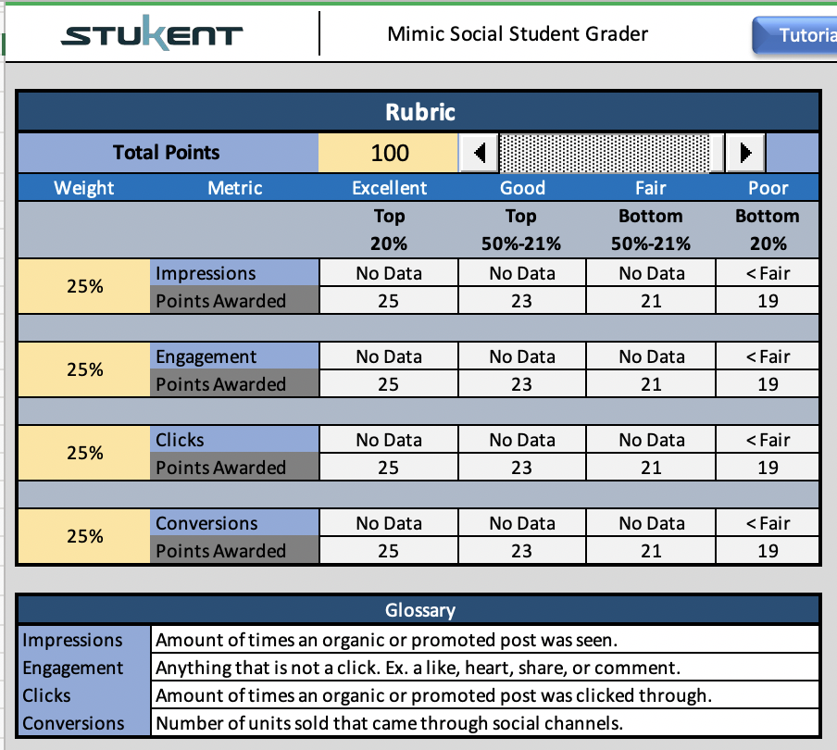

Appendix Three: Writing Rubric

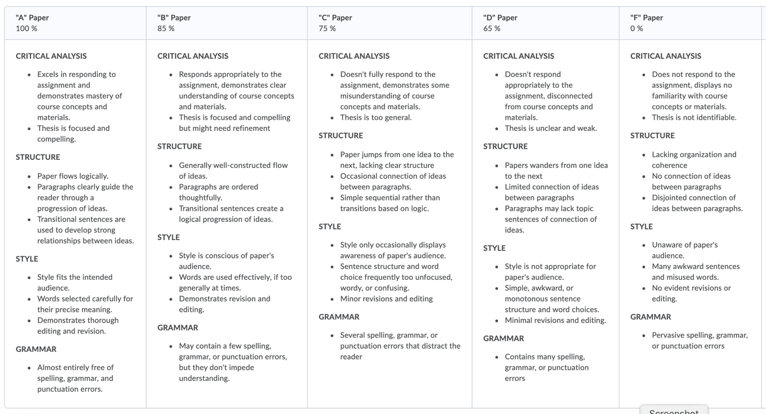

Appendix Four: Peer Evaluation
Peer Evaluation Form for Group Work

Your name ____________________________________________________
Write the name of each of your group members in a separate column. For each person, indicate the extent to which you agree with the statement on the left, using a scale of 1-4 (1=strongly disagree; 2=disagree; 3=agree; 4=strongly agree). Total the numbers in each column.

Evaluation Criteria | Group member: | Group member: | Group member: | Group member:
Attends group meetings regularly and arrives on time.

Contributes meaningfully to group discussions.

Completes group assignments on time.

Prepares work in a quality manner.

Demonstrates a cooperative and supportive attitude.

Contributes significantly to the success of the project.

TOTALS

Feedback on team dynamics:

- How effectively did your group work?

- Were the behaviors of any of your team members particularly valuable or detrimental to the team? Explain.

- What did you learn about working in a group from this project that you will carry into your next group experience?

Adapted from a peer evaluation form developed at Johns Hopkins University (October, 2006)

Endnotes

https://youtu.be/j6tKf1IR5j8 (week 2; Gary Vee exercise)
https://education.hootsuite.com/ (week 1)
https://medium.com/@taylorcharlesia/is-a-hootsuite-certification-worthwhile-1d2a363a541f#:~:text=With%20the%20Hootsuite%20certification%20comes,as%20on%20their%20LinkedIn%20page.&text=The%20others%20reported%20the%20certification,as%20leaders%20in%20the%20industry. Note: the article was written in 2016; also, the author paid for the service while students receive a free service/certification
https://digitalmarketinginstitute.com/blog/the-social-media-landscape-in-2020 (week 3)
"Invisible Skateboarder" by Photo Extremist is licensed with CC BY-ND 2.0. To view a copy of this license, visit https://creativecommons.org/licenses/by-nd/2.0/
"Tennis Shoes and Netting" by Theen ... is licensed with CC BY-NC-SA 2.0. To view a copy of this license, visit https://creativecommons.org/licenses/by-nc-sa/2.0/
"stilleto" by imagine.carlosmanuel is licensed with CC BY-NC 2.0. To view a copy of this license, visit https://creativecommons.org/licenses/by-nc/2.0/
"Invisible Skateboarder" by Photo Extremist is licensed with CC BY-ND 2.0. To view a copy of this license, visit https://creativecommons.org/licenses/by-nd/2.0/
"Tennis Shoes and Netting" by Theen ... is licensed with CC BY-NC-SA 2.0. To view a copy of this license, visit https://creativecommons.org/licenses/by-nc-sa/2.0/
"stilleto" by imagine.carlosmanuel is licensed with CC BY-NC 2.0. To view a copy of this license, visit https://creativecommons.org/licenses/by-nc/2.0/
"Invisible Skateboarder" by Photo Extremist is licensed with CC BY-ND 2.0. To view a copy of this license, visit https://creativecommons.org/licenses/by-nd/2.0/
"Tennis Shoes and Netting" by Theen ... is licensed with CC BY-NC-SA 2.0. To view a copy of this license, visit https://creativecommons.org/licenses/by-nc-sa/2.0/
"stilleto" by imagine.carlosmanuel is licensed with CC BY-NC 2.0. To view a copy of this license, visit https://creativecommons.org/licenses/by-nc/2.0/

