Unit 3: Postsecondary | Lesson 3.3 Impacts of Education
- Objective | Students will determine the costs and financial benefits associated with postsecondary degrees. Results will be shown graphically and mathematically as a return on investment ratio.
- Vocabulary | Compensation, Earnings, Return on Investment Ratio
- Engage | CLASS DISCUSSION: Remind students about the discussions we had in class from the Postsecondary Options lesson in which they identified the option category that was the best fit for them. Ask how many students have the college category as their best path. Discuss why college plays such an important role in their future plans.
- Explore | Discuss the following graphic that illustrates the weekly earnings and unemployment rates that accompany various education levels.  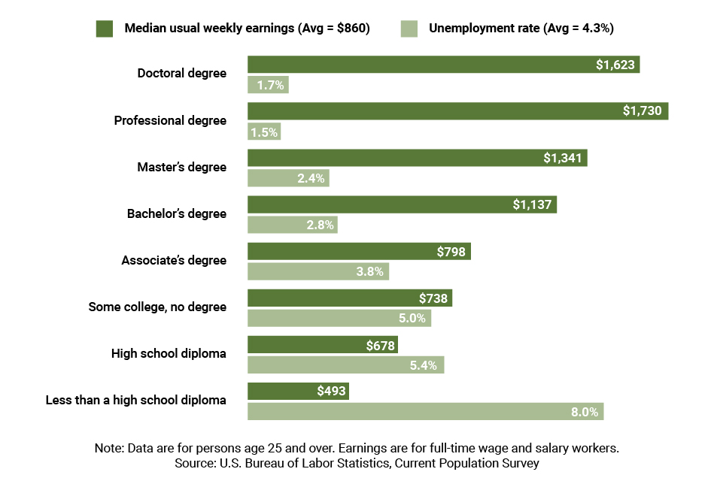
- Elaborate  - Elaborate Con.  - Elaborate Con. | Financial Analysis of the College Decision:  Career After High School:  - Education debt: None  - Median annual salary over career: $35,724  - Immediate earnings  College After High School (Bachelor’s):  - Education debt: $33,000  - Median annual salary over career: $59,124  - Delayed earnings: 4 years  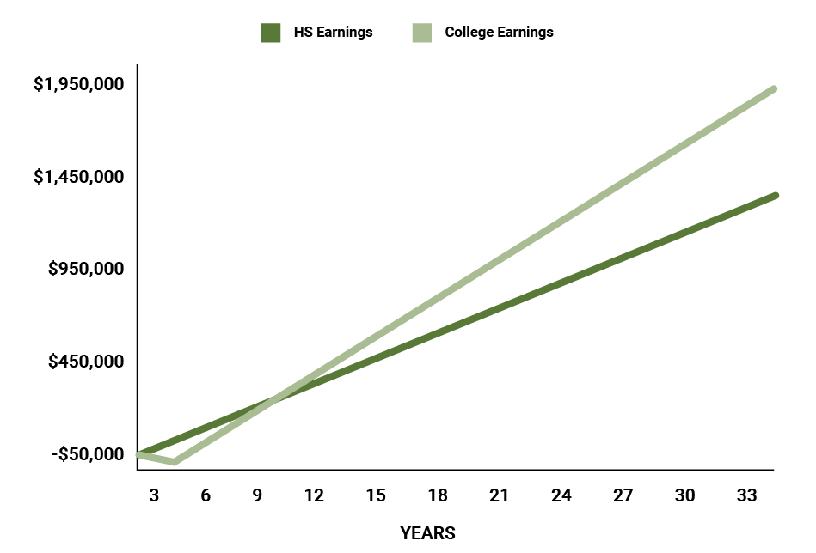  Discuss with students the above graphic which illustrates the lifetime earnings of two median annual incomes based on education level. Point out that in this graph it assumes median earnings from throughout the career. Ask students the following questions:  - How long before the college degree becomes financially “worth it”?  - What is the approximate difference in total lifetime earnings?  Calculating the ROI of College Degrees:  ROI: Return ON Investment  - How much will you make off of your investment?  - Sometimes discussed as return OF investment in which case the investor is concerned with how long it will take to get their initial investment back.  - In this course, we will refer to the return ON investment when using the term “ROI”  Calculate ROI by dividing the benefit (return) of an investment by the cost of the investment and expressed as a percentage ratio:  $$\left(\frac{Benefit}{Cost}\right)×100=ROI\%$$  - EX: You get a degree that costs $50,000 that allows you to get a job that pays $60,000 a year.  - Step 1: Find the “benefit” by subtracting the cost of the degree from the total profits earned from the yearly salary.  $$Total Profit-Cost=Benefit$$  $$\$60,000-\$50,000=\$10,000$$  - Step 2: Divide the benefit by the cost  $$\left(\frac{\$10,000}{\$50,000}\right)×100=20\%$$  - This can be interpreted to say that in one year you will get a return of all of your investment plus an ROI of 20%.
- Evaluate | My Career ROI: Have students go to the site at the following link (post this link to your own class website so students do not have trouble typing it in):  http://www.bankrate.com/finance/college-finance/roi-college-degree.aspx  This site lists a number of different occupations along with relative information regarding necessary education, cost of degree, and annual net salaries.  Have students determine the ROI for the first two occupations listed: Advertising, etc. & Economist. Their ROIs are 42% and 19% respectively.  Question: Just by looking at the cost of the degree and the expected net salary, what can you say about the ROI of a Veterinarian?  - There is a negative benefit.  - This means that in order to get an ROI, you must consider more than one year. This is an example when the Return OF Investment should be taken into consideration when making career decisions.  Have students do some research online to find the cost of the degree they are most interested in as well as the annual salary (if net is not available they should multiply gross by 0.75) of the career they want to have. Once they have done this, have them calculate their respective ROIs and then write them along with the career on the board for comparisons. Pick one or two and create a line graph illustrating the cost-over-time relationship.
- Resources | http://www.bankrate.com/finance/college-finance/roi-college-degree.aspx  PowerPoint Presentation: 4.3 – The Impacts of Education
- References | https://nces.ed.gov/  http://www.bls.gov/emp/ep_chart_001.htm  https://www.debt.org/students/  Excel Spreadsheet 3.3: Median Lifetime Earnings Data

